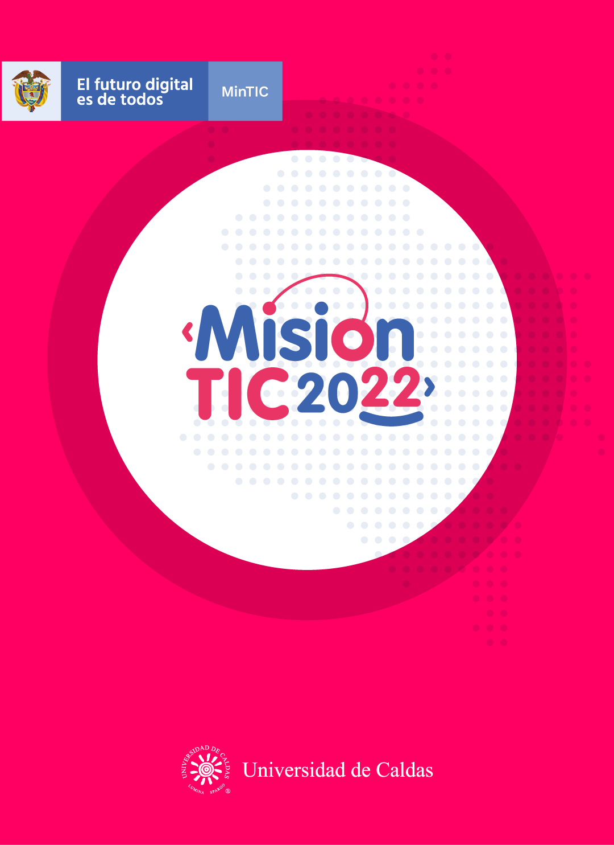

**ENGLISH COMPONENT – CYCLE 4 SESSION 2**

**ANDROID STUDIO**

**WORKSHEET 4.2**

**Worksheet 4.2.1**

**Warm-up**

**Do you remember these words? Can you create some sentences with them?**

* “Develop”**:**
* ”Developer”**:**
* “Development”**:**
* “Developing”**:**

**Worksheet 4.2.2**

**Vocabulary**

**Write the definitions or translations for the next words.**

* Skyrocketing**:** increase rapidly/fast:algo que tiene un aumento rapido ó repentino
* Development Environment**:** software to create code/entorno de Desarrollo
* Powerful**:** poderoso/mighty
* Features**:** caracteristicas/characteristics
* Configured**:** estructurado,configurado/ formed,customized,modified settings
* Once**:** Una vez/one time
* Download**:** descarga/descargar-transfer-share data
* Behavior**:** comportamiento -mood,conduct,habits
* Empty**:** Vacio-null,clear,delete,unoccupied

**Worksheet 4.2.3**

**Vocabulary Practice**

**Drag and drop the new words in the right spaces.**

|  |  |  |
| --- | --- | --- |
| * Skyrocketing. * Development Environment. * Powerful. | * Features. * Configured. * Once. | * Download. * Behavior. * Empty. |

**1.** I thought my PPT presentation was on my USB, but when I inserted it in my computer and opened it, it was **___empty_______** there were no files on it.

**2.** The latest Mac is very **_powerful_________**: it is very fast, it has good memory and it has the best processor.

**3.** **___once_______** you finish school, you should think about applying to a university to continue your studies.

**4.** When the pandemic started, there was a **_skyrocketing_________** increase in the use of e-commerce websites.

**5.** **____development enviroment______** is the software that allows you to create applications.

**6.** I wanted to **___download_______** a digital book, but I had to pay for that. If you don´t pay, you can only read it online.

**7.** The new model of Xiaomi cellphone has many new **__features________** that the previous models didn´t have.

**8.** I decided to learn Portuguese this year, so I **_configured_________** my cellphone in that language. Now all the menu appears in Portuguese.

**9.** My teachers tell me that I have to improve my **____behavior______** my grades for discipline are very low!

**Worksheet 4.2.4**

**Reading strategy**

Watch the video and answer the task. <https://www.youtube.com/watch?v=W8qmj4oY9mY>

1. What is visualizing?

**Create a mental image of something**

1. How can visualizing a text improve my reading comprehension?

* It helps readers better recall the main ideas of the text
* The text the meaningful and memorable
* It can help us remember details
* It gives up ownership of the text

1. **Write adjectives to the five senses**

* Seeing**: looking,viewing,watching**
* Hearing**: listening,detecting**
* Tasting**: bitter,greasy,bland,tasteless**
* Touching**:** feeling,textures
* Smelling**: scents**

**Worksheet 4.2.5**

**Reading Task**

In the text below you will see this: **[Logo: __]** . You should match the right logo with the right place in the text by writing the number of the logo in each space.

|  |  |  |
| --- | --- | --- |
| 1 Windows 7 - Wikipedia, la enciclopedia libre | Macos sierra os x mavericks, manzana, ángulo, logo png | PNGEgg2 | Image result for android studio3 |
| Kotlin Programming Language4 | Logo Intellij IDEA PNG transparente - StickPNG5 | Android robot logo vector - Free download logo of Android robot in .AI  format6 |
| Java Logo PNG Images, Free Transparent Java Logo Download - KindPNG7 | Amrit Foundation of India download-logo - Amrit Foundation of India8 | Free download Linux logo | Vector logo, Linux, Logos9 |

Note: Some logos are repeated.

**Worksheet 4.2.6**

**Reading**

**Android Studio**

With over 2.7 billion smartphone users in the world, it’s not surprising that [Android app](https://www.edureka.co/blog/android-tutorial/) **[Logo: _6_]** use is **skyrocketing**. This article on Android Studio Tutorial will help you understand how to develop an application on the Android Studio platform.

**What is Android Studio? [Logo: _3_]**

Android Studio is the official Integrated **Development Environment** (IDE) for [Android app development](https://www.edureka.co/blog/how-to-create-android-apps/), based on IntelliJIDEA **[Logo: _5_].** Apart from IntelliJ’s **powerful** code editor and developer tools, Android Studio offers even more **features** that make you more productive when creating Android apps **[Logo: 6__].**

**Setting up Android Studio**

One of the most convenient factors about Android Studio is that you can start developing [Android applications](https://www.edureka.co/blog/android-tutorial/) **[Logo: __]** on any of the operating systems. It can be Microsoft Windows **[Logo: _1_]**, Mac OS **[Logo: 2__],** or Linux **[Logo: _9_].**

Now to start with the implementation part, we need to install the following software’s:

* JDK – Java Development Kit **[Logo: _7_].**
* Android Studio **[Logo: _3_].**

1. JDK Installation **[Logo: 7__].**

The [Java Development Kit (JDK)](https://www.edureka.co/blog/what-is-java/#ComponentsinJava) is a software development environment used for developing Java applications. It is necessary to have JDK **configured** on your system. **Once** you

configure JDK, you can continue with the Android Installation.

2. Android Studio **[Logo: 3__].**

Go to this link: <https://developer.android.com/studio/index.html>  and **download** **[Logo: 3__]** the latest version of Android studio. Once the Android Studio is configured, you can start creating the first Android App **[Logo: _6_].**

**Creating a First Android Application**

1. Once Android Studio **[Logo: 3__]** is downloaded **[Logo: _8_],** open Android Studio and click “Start a new Android Studio project” on the Welcome screen or File > New > New project.

2. Select an [activity](https://developer.android.com/guide/components/activities/intro-activities) that defines the **behavior** of your application. For your first application, select **Empty** Activity that just shows a screen, and click Next.

3. After that, you need to choose the preferred Programming language and click the Next button. You can either choose Kotlin **[Logo: 4__]** or Java **[Logo: _7_]** programming language.

4. Below snapshot represents the home page of Android Studio **Logo: _3_].**

**Worksheet 4.2.7**

**Wrap-up: Reading comprehension.**

**Look at the image. You can see that there are 4 parts in the image that are numbered from 1 to 4. Match the descriptions below with the correct part of the image.**

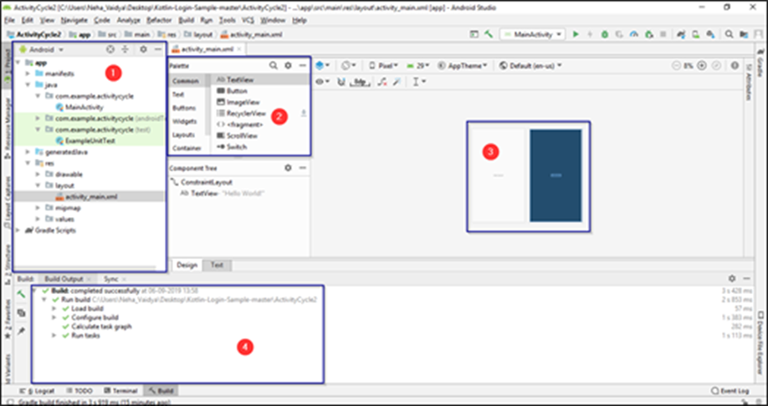

1. This window is a Palette which consists of a component that is essential for creating an application. You can add a

button, layout, image as per the requirement on to your app window. **[ 2_ ]**

2. This is a console in Android Studio which displays the result and the configuration tasks. **[ _1 ]**

3. This is a section where you can actually create your Android application using the Palette components. All that you need to do is – just drag and drop the components. **[ 3_ ]**

4. This section represents the project structure of an Android Application which consists of the layout, result, and Gradle scripts. **[ _5 ]**

**Worksheet 4.2.8**

**Self-Evaluation**

**Complete the following self-evaluation section.**

1. Entiendo qué es Android Studio.

**Yes 😃 Maybe 😐 No 😟**

2. Entiendo en qué consiste la estrategia de “Visualizing”.

**Yes 😃 Maybe 😐 No 😟**

3. Pude usar la estrategia visualizing en el texto de esta clase usando los logos famosos.

**Yes 😃 Maybe 😐 No 😟**

4. Visualizar los logos me ayudó a seguir el texto más fácil.

**Yes 😃 Maybe 😐 No 😟**